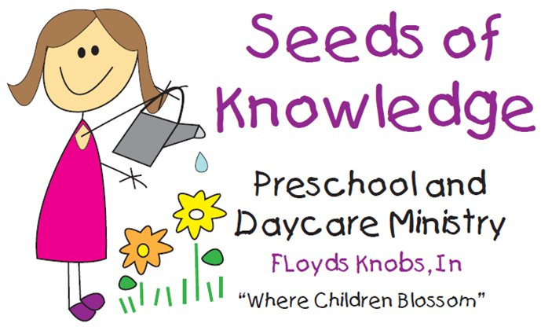

I hereby give Seeds of Knowledge permission to take pictures and videos of my child(ren), for the purpose of posting on all Seeds of Knowledge social media sites and/or publications and materials.

I agree that my child(ren)’s identity (please initial one):

______ May be revealed

______ May not be revealed

_____________________________
Child’s Name

_____________________________
Parent/Guardian PLEASE PRINT

_____________________________
Signature or parent/legal guardian

Like us on Facebook (Seeds of Knowledge Preschool and Daycare) and Instagram Seeds of Knowledge LLC!

